Cloud Computing Overview (AWS CLI)

HOS08: Amazon DynamoDB (DDB)

Developed by Marvin Gold 12/20/2020

Reviewed by Kim Nguyen class of 2021

School of Technology and Computing



**Learning Outcomes**

* Create a table
* List tables
* Add an item to a table
* Delete an item from a table
* Delete a table

**Background**

Amazon DynamoDB is a NoSQL Document Database that is incredibly scalable. DDB is a common part of serverless architecture using AWS. It uses Key, Value pairs to save values to the table.

**References**

https://docs.aws.amazon.com/cli/latest/userguide/cli-services-dynamodb.html

<https://aws.amazon.com/dynamodb>

<https://aws.amazon.com/dynamodb/getting-started/>

https://docs.aws.amazon.com/amazondynamodb/latest/developerguide/Introduction.html

**Step 1: Log onto your Amazon EC2 Instance**

Log onto your Amazon EC2 instance using either OpenSSH, Putty, or from the AWS Management Console using ‘EC2 Instance Connect’ (shown below). Note all IP addresses used in this series of Hands on Skills will be released by the time we start class.

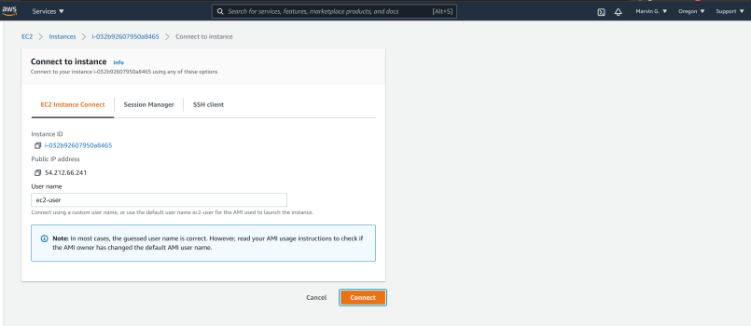

If you receive an error that you must first set your AWS Region and you must configure your AWS CLI, please follow these instructions.

<https://docs.aws.amazon.com/cli/latest/userguide/cli-configure-quickstart.html>  
  
Remember, do not use your root *account* for these operations. You should be using another IAM user. You should not have access keys to your root account.**Step 2: Create a DynamoDB table**

Amazon DynamoDB use a *primary key* to uniquely identify items in the table. So it is important to use something that is unique, like ID number or SKU.

First we are going to make a table, describe the attributes, the key schema, and the throughput.

Create the table in the snippet below

You can use aws dynamodb list-tables to show all the tables in your account

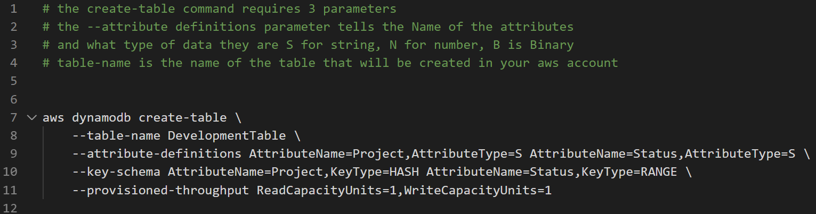  
  
 **Attach a SCREENSHOT of your OUTPUT**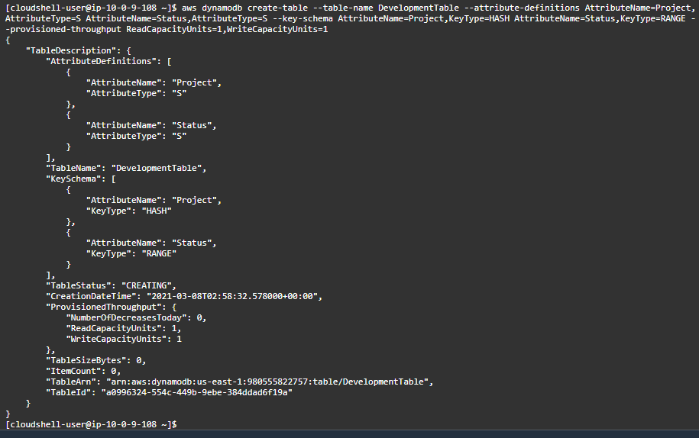

**Step 3: Add an item to the table**

We are going to add an Item to our Development table we are going to add a Project named   
SchoolRecordSystem and give it a status of Planning and we are going to put the budget in as well of 100,000. We want to see how much of our throughput we are using so we will add the –returned-consumed-capacity TOTAL

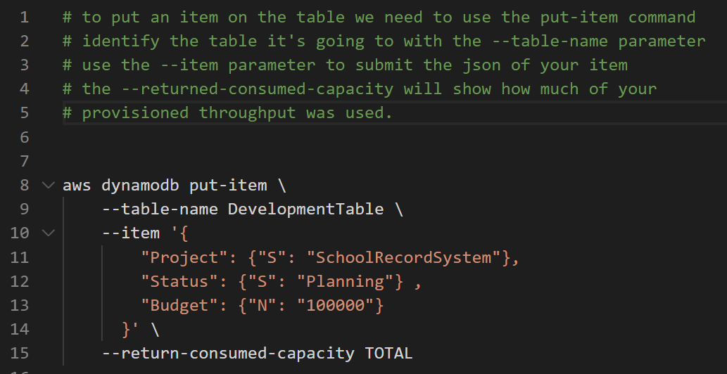  
  
**Attach a SCREENSHOT of your OUTPUT**   
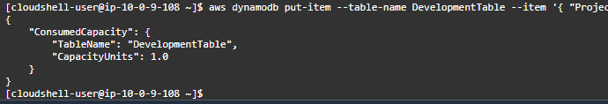

Add 3 more projects to the table with different project names , with a status of either

InProgress, Complete, Planning, Blocked and a budget between 10,000 and 500,000

**Attach SCREENSHOTs of your OUTPUTs**

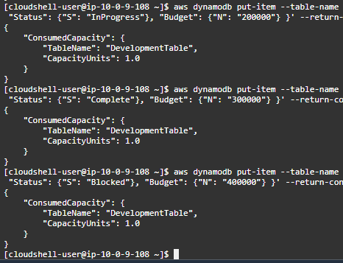

**Step 4: Deleting Items**

To delete an Item from a table we use the delete-item command.

Use the API guide to find out how to delete an item. And delete the School Record System Item

<https://docs.aws.amazon.com/cli/latest/reference/dynamodb/delete-item>

**Attach a SCREENSHOT of your OUTPUT**

**Step 5: Delete a Table**

To delete a table use the delete-table command.

**Attach a SCREENSHOT of your OUTPUT**